Getting Closer Marriage Lecture
BS”D

What is Attachment Theory?
Attachment theory is focused on the relationships and bonds between people, particularly long-term relationships including those between a parent and child and between romantic partners.
Attachment is an emotional bond to another person and a lasting psychological connectedness between human beings.

Attachment Vs. Detachment
Closeness
Distance

- Rejected
- Abandoned
- Not measuring up
- Detached
- Helpless
- A failure
- Not accepted or valued
- Unlovable
- Secure
- Safe
- Happy
- Attached
- Connected
- Valued
- Lovable
- Appreciated

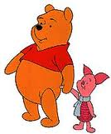
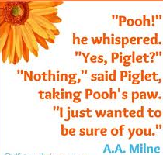
What Creates Attachment?

- Appreciations
- Getting to Know One Other
- Love Languages
- Active Listening
- Understanding Attachment-Style Differences
- Increasing Intimacy

- Appreciations
Exercise:
- affectionate
- amicable
- amusing
- brave
- bright
- calm
- compassionate
- creative
- decisive
- easygoing
- enthusiastic
- faithful
- friendly
- funny
- generous
- gentle
- hard-working
- helpful
- honest
- humorous
- imaginative
- modest
- neat
- passionate
- patient
- romantic
- sensitive
- sincere
- sympathetic
- thoughtful
- understanding
Choose 3 characteristics you appreciate about your spouse and share incidents when they occurred.
- Getting to Know One Another
Based on the writings of Dr. John Gottman
Exercise:
Please write down answers to these important questions and do not share with your spouse. After you are done then share them with your spouse
1. My spouse’s closest friends are (list names) ________________________________________________________. 2

2. My spouse is currently stressing out over _________________________________________________________. 2

3. Some of my spouse’s life dreams are _____________________________________________________________. 3

4. One of my spouse’s favorite outfits is ____________________________________________________________. 2

5. My spouse’s basic philosophy on life is ___________________________________________________________. 2

6. The relatives my spouse likes the most are ________________________________________________________. 2

7. My spouse’s favorite music is
___________________________________________________________________. 1

8. My spouse’s favorite videos are ________________________________________________________________. 2

9. My spouse’s favorite getaway place is ____________________________________________________________. 2

10. The three most special times in my spouse’s life were _______________________________________________. 3

After you confirm the answers with your spouse, add up the numbers and see who one!
Total:________

- Languages of Love
By Dr. Gary Chapman

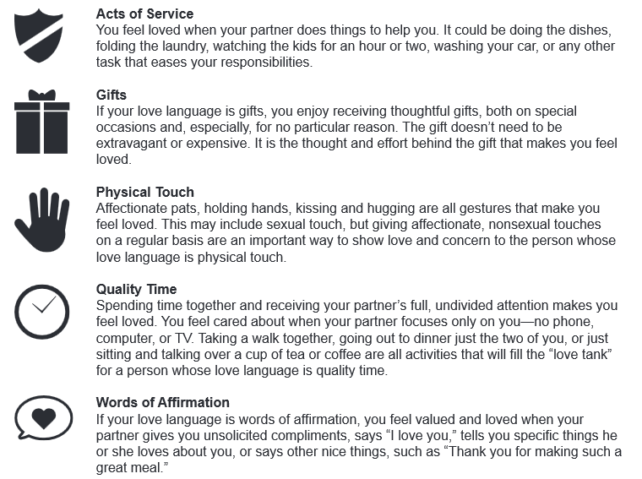

Exercise:
Choose and discuss your “love language” with your spouse.

4. ACTIVE LISTENING AND “I” MESSAGES
Below are four core principles of active listening.

1. Physical Attention
• Face the person who is talking.
• Notice the speaker’s body language; does it match what he/she is saying?
• Can you match the speaker’s body language?
• Try not to do anything else while you are listening.

2. Paraphrasing
• Show you are listening and understanding what is being said.
• Restate basic ideas and facts.
• Check to make sure your understanding is accurate by saying:
“It sounds like what you mean is... Is that so?”

3. Reflecting
• Show that you understand how the person feels.
• Help the person evaluate his or her feelings after hearing them expressed by someone else.
• Reflect the speaker’s feelings by saying:
“Are you saying that you’re angry/disappointed/glad, because...?”
“It sounds like you feel...”

4. Clarifying
• Help clarify what is said.
• Get more information.
• Use a tone of voice that conveys interest.
• Ask open ended questions, as opposed to yes/no questions, to elicit more information.

5. Encouraging
• Show interest by saying
“Can you tell me more about that?”
“Really?”
“Is that so?”

“I” Messages
“I” messages focus on what you feel about someone’s behavior and simply state a problem, without blaming someone for it. This makes it easier for the other person to help solve the problem, without having to admit that they were wrong.
“I” messages usually contain four elements:
(1) How I feel about the behavior and its effects
(2) A description of the behavior, what actually happened
(3) The actual, concrete, tangible effects of that behavior on you
(4) The behavior you would prefer
Another way they can be expressed is like this:
I feel _________________ (express your feeling)
when this happens _____________ (describe the action that affects you or relates to the feeling)
because _______________ (explain how the action affects you or relates to the feeling)

Attachment and “I” Messages
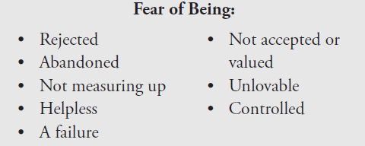

Exercise: Talk about your feelings to your spouse while your spouse actively listens to you. Chose a time when you felt sad, scared, helpless etc.. Remember not to blame, but express your feelings using an “I” message.
- Understanding Attachment Styles

Check the small white box if a statement is TRUE for you. (If the answer in untrue, don’t mark the item at all and move onto the next question.)

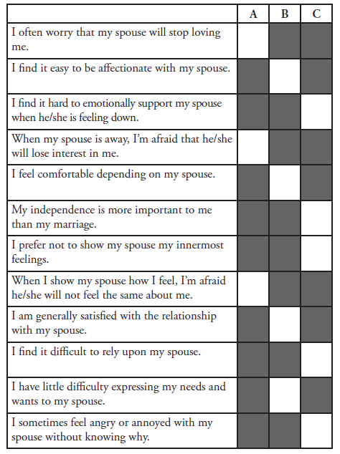

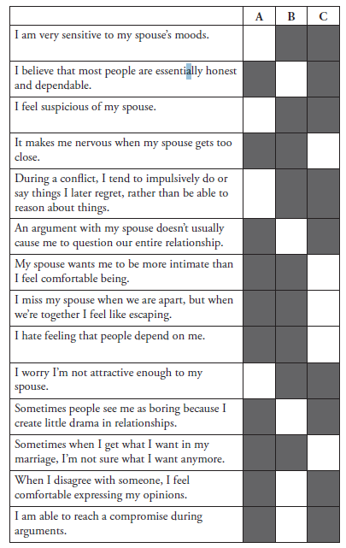

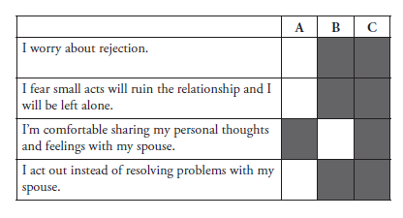

Add up all your checked boxes in column A:__________
Add up all your checked boxes in column B:__________
Add up all your checked boxes in column C:__________

The more statements you choose in a category, the more you will display the corresponding attachment style. Category A represents the anxious attachment style, category B represents the secure attachment style, and category C represents the avoidant attachment style.

If you are still not sure what your attachment style is, choose one of the three next statements that summarize attachment styles:

Secure: Being warm and loving in marriage comes naturally. I enjoy being intimate and don’t get easily upset over relationship matters. I effectively communicate my needs and have the capacity to empathize with my spouse.

Anxious: I love being close with my spouse, but I’m often worried he/she doesn’t really love me. I experience a lot of negative emotions and get upset easily.

Avoidant: It is very important for me to maintain my independence and self-sufficiency. I tend to protect my emotions from my spouse and I’m on high alert for any signs of control or impingement on my territory.

The Attachment Dance
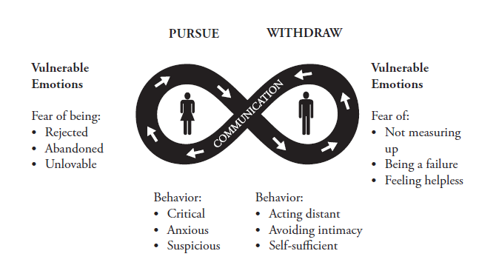

References for Getting Closer Workshop
Chapman, G.(1992). 5 Love Languages
Gottman, J. (2000). The Seven Principles for Making Marriage Work
Johnson, S. (2009). Hold Me Tight: Seven Conversations for a Lifetime of Love

